Youth Participation Strategy

Dorset Police and Crime Commissioner

Introduction
As Police and Crime Commissioner, our communities often spend a great deal of time talking to me about how we can better support our children and young people.
Our children and young people should have safe spaces to gather and have access to support which helps them develop into productive and resilient adults.
Children and young people continue to be disproportionately affected by crime which needs to change. My Office has continued to invest in interventions to divert children and young people at risk away from criminality but there is more to be done.
That is why I am pleased to commit to this strategy, designed to help us listen to children and young people who can help us shape our plan to better support vulnerable children and young people in the future.

I look forward to seeing both the practical implementation of this strategy and the positive results it will bring to communities across Dorset. The National Children and Young Persons Policing Strategy
The national Children and Young Persons Policing Strategy has set the ambition for the UK to have “the most trusted and engaged policing service in the world working together to make communities safer and stronger”. This Participation Strategy will help us ensure that the Office of the Police and Crime Commissioner along with Dorset Police, is developing strategies which are shaped by children and young people’s lived experience. It will enable us to demonstrate we have not simply listened to the voices of children and young people; our actions will show we have heard them.

Our Commitment
Our vision is to co-create and co-commission services for children and young people WITH children and young people which help grow a safer Dorset. We will listen, act, and respond to the views of children and young people living in Dorset by making sure we create safe spaces to facilitate conversations.

Our Commitments

Listen
We want to hear from ALL young people living in Dorset so we will work with partners to create spaces and places for us to listen to young people that are interesting, engaging, and accessible.

Act
We will work with young people to create opportunities, improve services, and build a better future.

Respond
We promise to respond to the young people we listen to, letting them know the difference they have made after we have had time to act.

Repeat
We will constantly review our approach and make improvements along the way.

Our Approach
This strategy sets out a three-year plan to build on existing, well-established structures which support decision makers to listen to the voice of young people across Dorset.
We are committed to getting things right so we will ensure we grow our approach, allowing time for regular evaluations and improvements. Our approach will be broken down into three main areas of development to ensure we hear a wide breadth and depth of voices.
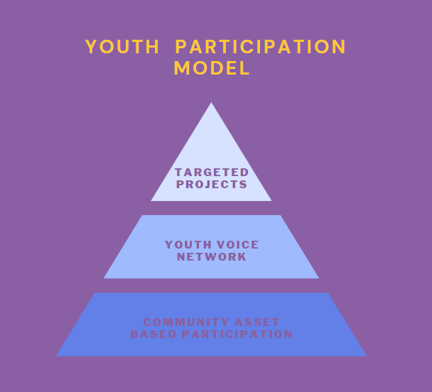

Community Asset Based Participation
Community Asset Based Participation builds on the well-established assets found within the community with trusted adults who young people have already developed a relationship with. This approach helps us to listen to a wider breadth of voice and the voice of marginalised young people.
Rather than establishing a new structure to listen to young people, we will work with groups such as Dorset Council’s targeted youth workers, BCP Council’s Children’s Rights and Engagement team, Dorset Combined Youth Justice Service and the Community Action Network (CAN). This will support young people to feel safe in sharing their views as they will be working with professionals they trust.
The OPCC will create a quarterly participation pack which will include questions and themes we want to hear young people’s views on. Community Assets will seek to capture young people’s views and opinions. This may be in the form of a questionnaire, peer interviews or a group discussion. Community Assets will then feedback the voice of those young people they are engaging with.

Youth Voice Network
As we build trust with young people through the community asset-based participation in Year 1, we will seek young people’s views on the ideal approach to a youth voice network. This could be a formal group made up of representation from each community asset group or a regular opportunity to bring young people together in another format. For example, a hybrid event where several groups or young people as individuals, come together to share their voice and agree actions. The Youth Voice Network will be consist of young people who have a particular interest in crime prevention and appropriate support services for young victims of crime.
The Youth Voice Network will involve a smaller group of young people and will provide a platform for the voice of those with lived experience.

Targeted Projects
We will work with partners to build safe spaces for young people to share their lived experience related to specific areas of work. It is not always safe for young people to share their lived experience in a group setting and for young people to receive the right level of after care. Targeted projects will work with small groups of young people and will help us understand the lived experience of young people accessing services in Dorset.
Targeted projects will offer a one-to-one opportunity to be heard by a trained professional on a specific issue, for example, knife crime. We will work with partners to ensure this is conducted ethically and does not further traumatise young people who may have already experienced trauma in their lifetime.

Feedback loop
To ensure the OPCC’s Youth Participation Strategy is meaningful for young people, voice is not enough. We need to facilitate a two-way ongoing conversation where young people see their influence on decision making.
Working with community assets in year one, we will facilitate a feedback loop so young people understand the difference their voice is making. In year one, we will create a quarterly cycle which will look like this:
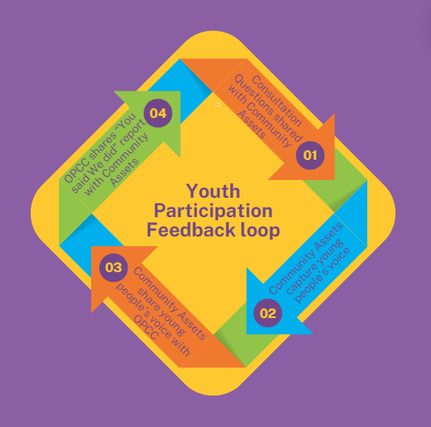
We will review the feedback loops at the beginning of each quarter, improve and adjust to better meet the needs of the young people involved.

How we will measure success
There are a number of performance indicators we will monitor throughout the three-year strategy to measure success.
Measure | Indicator | Evidence
Young people actively engage with OPCC through the three routes of participation. |  | Numbers of participants
A diverse group of young people representing all affected populations including vulnerable and marginalised groups are supported to engage and feel heard |  | Demographic data  List of Community Assets involved
Young people are satisfied with the level and type of engagement offered |  | Feedback forms
Young people have an improved awareness of the activity of the OPCC |  | Feedback forms
The OPCC has an improved understanding of the lived experience of Dorset young people |  | “You Said We Did” Report
The OPCC commits resources to support ongoing youth participation
The OPCC sees the value of and listens to the voice of young people when commissioning services for Dorset’s youth. |  | Youth Voice embedded in commissioning process

Children and Young Persons Policing Strategy 2024-2027

